Indiana University Purdue University
Date February, 20th 2017

PROJECT PROPOSAL

Product Recommendations on Amazon Products
By
Sindhu Balakrishnan
Ashwini Kulkarni

Table of Contents
1. Abstract 3
2. Application Areas: 3
3. Technology: 4
4. Dataset/ Data source 5
5. Output Expected: 6
6. Time Schedule 6

Abstract

Goal of the project is to build a recommendation system which would suggest the user with products which has a likelihood that he/she might prefer to buy.
This methodology is similar to suggested products section in Amazon website:
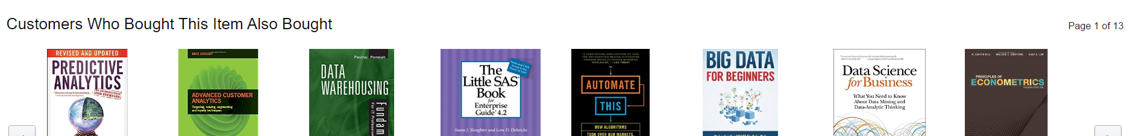
Fig. 1.1

Application Areas:

This project methodology can be applied in domains where historical order information is available. This includes but not limited to systems like online retail sites, movie/ restaurant recommendations etc.

Technology:

Platform: Hadoop
Processing Paradigm: Map-reduce, Spark, Oozie, Hive
Programing language: JAVA

Implementation methodology:
- This implementation requires data to be available in a standard format like json or csv.
- Data Extraction: The dataset will be loaded to HDFS
- Develop Mapper program:
Input: Search for a book
            - Program finds the past list of books bought by the user - List A
            - Program searches the whole dataset and returns users who have bought books in List A
            - Find all the books bought by those users – List B
            - For each book in list B find maximum sold books - List C
            - Recommend the top 10 books from list C
- We will be using Combiner as needed.
- The results will be collated in the reducer and write it back to HDFS.

Dataset/ Data source
Dataset used is historical Amazon books review from:
http://jmcauley.ucsd.edu/data/amazon/
Dataset: Amazon Books (5-Core) (JSON format)
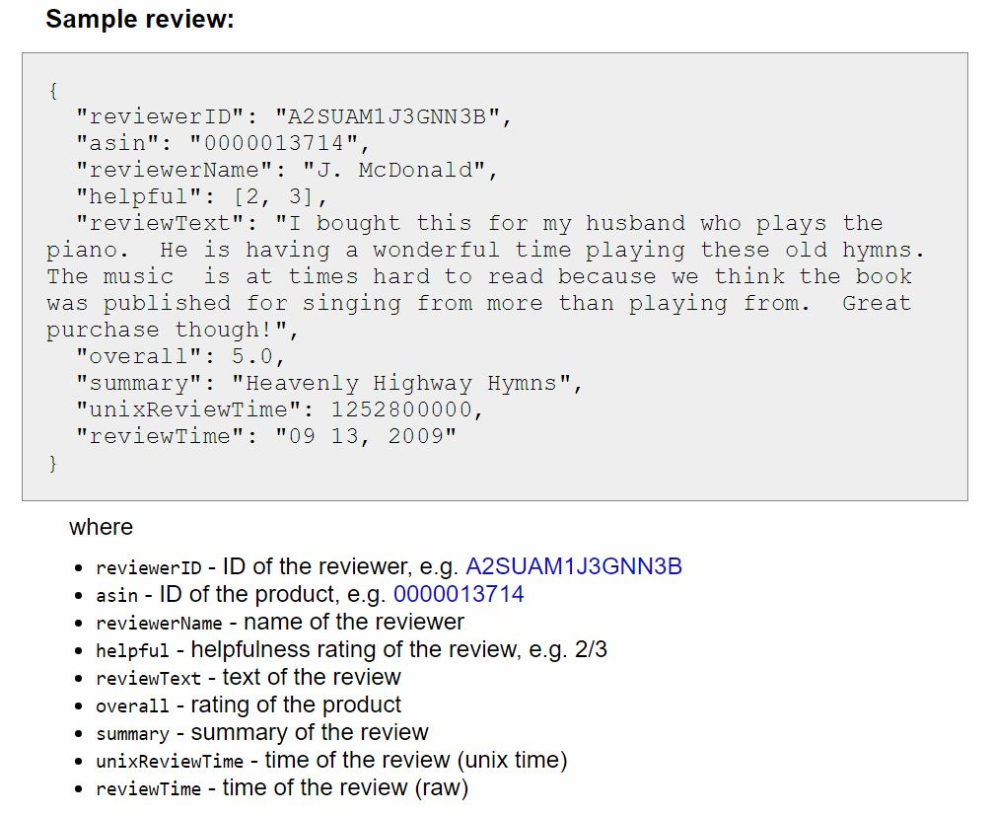
Fig. 1.2
This dataset contains book reviews from Amazon, including 142.8 million reviews spanning May 1996 - July 2014. This dataset includes reviews (ratings, text, helpfulness votes).
We are mainly focusing on following two features in our implementation.
Feature | Description
User ID | Contains reviewer ID
Product ID | Unique ID for Each Product

Output Expected:
On specifying product id and user id as input, it should return top book suggestion after spanning through 142.8 million book reviews within a reasonable period of time. (Refer fig 1.1)

Time Schedule
Provide detailed information on the expected timetable for the project. Break the project into phases, and provide a schedule for each phase.
 | Description of Work | Start and End Dates
Phase One | Extracting and analyzing Data | 1st Mar - 17th Mar 2017
Phase Two | Mapper and reducer Development | 17th Mar - 6th Apr 2017
Phase Three | Testing | 7th Apr - 18th Apr 2017

- Reference:
http://jmcauley.ucsd.edu/data/amazon/

